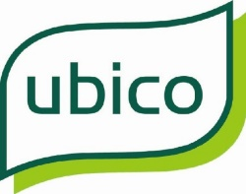
Ubico Ltd
Welcome to Gloucestershire Sharps Collection Service

Brief overview:
We have provided you with 40 litre bins that all sealed Sharps canisters must be put into ready for a monthly collection, if you require a further collection that month the contact details are listed below, and we will do our best to accommodate you.

If your collection falls on a bank holiday, we will plan it into our schedule.

On arrival our driver Les will take your full bins and replace with empties, and you will need to sign a copy of the hazardous waste consignment note of which a copy will be left with yourselves.

If you have any queries, please do not hesitate to contact us.

Driver: Les Minchin
Email: Sharps@ubico.co.uk
Mob: 07796434071
Office: 01452 504541
Other contact names are:
David Jones - Operations Manager
Ian Donnachie - Supervisor
Mark Smith - Supervisor
Laura Tiley - Performance & Data Supervisor

